Levi Bike Showroom

Levi is a bike company, and they have their showrooms at many places in the city. When a customer books a bike from a showroom, the bike is delivered within the next 10 days. Levi showroom management wants to automate their bill payment as processing them manually is tedious. Create a web page for them to calculate the on-road price along with the showroom price, insurance amount and RTO charges. On submitting the details, the message has to be displayed on the same page as shown in the screenshots below.
Plain web page :
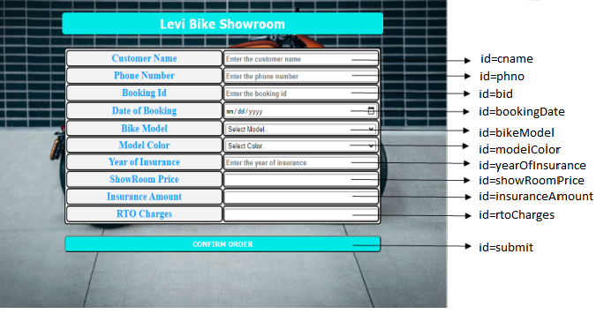
Web page after placing valid inputs (until Year of Insurance) and clicking on CONFIRM ORDER button.
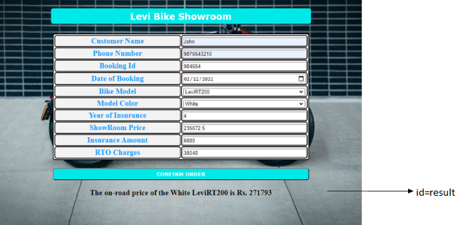

Use the Label Name and the Component Id as given. All the necessary attributes for the Components should be given. The Component Id should be specified for each HTML Component. If the Component Id is not provided for an HTML component, marks will not be provided for that component. All Tags, Elements and Attributes should conform to HTML5 Standards. All the fields are mandatory.

Provide the details as given in the table below.
Req. # | Req. Name | Req. Description
1 | Design an HTML page for “Levi Bike Showroom” application | Note: The text highlighted in bold in the Description needs to be implemented in the code to complete the web page design.
  Label Name | Component Id  (Specify it for the “id” attribute) | Description
  Customer Name | cname | To enter the name of the customer.  Design Constraints:  - The text “Enter the customer name” should appear by default.  - It should be mandatory.  - Use type=“text” with pattern attributes to accept the alphabets and space only.
  Phone Number | phno | To enter the phone number of the customer.  Design Constraints:  - The text “Enter the phone number” should appear by default.  - It should be mandatory.  - Use type=“tel” or use type=“text” with pattern attributes to accept the 10 digit mobile number that starts with either one of the following numbers: 7,8 or 9
  Booking Id | bid | To enter the booking id of the bike.  Design Constraints:  - The text “Enter the booking id” should appear by default.  - It should be mandatory.  - Use type=“number” or use type=“text”
  Date of Booking | bookingdate | To enter the booking date.  Design Constraints:  - Use type=“date”  - It should be mandatory.
  Bike Model | bikeModel | To select the bike model.  Design Constraints  Use the drop down box with “Select Model..”, “LeviRT200”, ”LeviRT150” and “LeviUltimate350” as options.
  Model Color | modelColor | To select the model color.  Design Constraints  Use the drop down box with “Select Color..”, “White”, ”Gray” and “Black” as options.
  Year of Insurance | yearOfInsurance | To enter the year of insurance. The text : ”Enter the Year Of Insurance” should appear by default.  Design Constraints:  - Use type=“number”  - It should be mandatory
  ShowRoom Price | showRoomPrice | A read only field that displays the showroom price.  Design Constraints:  - Use type=“number”  - It should be mandatory
  Insurance Amount | insuranceAmount | A read only field that displays the insurance amount.  Design Constraints:  - Use type=“number”  - It should be mandatory
  RTO Charges | rtoCharges | A read only field that displays the rto charges.  Design Constraints:  - Use type=“number”  - It should be mandatory
   | submit | Submit Button to submit the form  Design Constraints  - The input type should be “submit” and its value should be CONFIRM ORDER
2 | Apply the mentioned styles using CSS to the components | STYLING WITH ELEMENT SELECTORS  - HEADING (refer to screenshot) should be specified using <h3> tag.  Its color must be #FFFFFF and the background-color must be #00E6E6.  The margins: margin-left and margin-right must be auto.  The text-align must be center and width 50%.  The font-family of the text must be Verdana.  The padding and border-radius must be 5px and 6px respectively.  - TABLE , tr and td must be styled with width as 50%.  The margins: margin-left and margin-right must be auto.  The border-spacing and border-radius must be 1px and 6px respectively.  Its color must be #0099FF and the background-color must be #F2F2F2.  The padding must be 1px.  - DIV tag used for presenting results must be styled with font-size as 20px.  The text-align must be center.  The margins: margin-left and margin-right must be auto.  STYLING WITH ID SELECTOR  SUBMIT component must be styled using it’s id as in :  Its color must be #FFFFFF and the background-color must be #00E6E6.  The margins: margin-left and margin-right must be auto.  The padding must be 5px and width must be 50%.  The font-family of the text must be Verdana and font-weight must be bold.  The border-radius must be 6px.  RESULT component must be styled using it’s id as in :  Its color must be #696969 and the font-size must be 20px.  Note: Fill in the style tag so as to have the given styles applied to the components. (Do not use Inline CSS)
3 | Use JavaScript for displaying the price details. | Use JavaScript for displaying the price details:  When the valid values are entered (until Year of Insurance) and the submit component is clicked, the showroom price, insurance amount and rto charges should be filled in the corresponding fields followed by the result statement :  “The on-road price of the model color bike model is Rs. on road price” in a div tag with id as “result”.  Refer to the tables given below to build logics :  Formula:  showRoomPrice= (Ex-show room price)+(modelColor price);  insuranceAmount=(InsuranceAmount per year) * (yearOfInsurance);  onRoadPrice=showRoomPrice+insuranceAmount+onRoadPrice;  Example: If the bike model is LeviRT200, model color white, and year of insurance 5; then…  showRoomPrice = 234500 + ( 234500*0.005) = Rs. 235672.5  insuranceAmount = 1520 * 5 = Rs. 7600  rtoCharages = Rs. 30040  onRoadPrice = 235672.5+7600+30040 = Rs. 273312.5  Note:  - Use Math.round() on onRoadPrice (only) to get rounded values  - Use the getElementById() function to retrieve the values.  - In Javascript, Please do not use “let”. Instead, use “var”.
  Bike Model | Ex-Show Room Price | Insurance Amount/ per year | RTO Charges
  LeviRT200 | 234500 | 1520 | 30040
  LeviRT150 | 175900 | 1367 | 25032
  LeviUltimate350 | 356790 | 1940 | 30721
  Model Color | Price
  White | 0.5% of Ex-Showroom price
  Gray | 0.3% of Ex-Showroom price
  Black | 0% of Ex-Showroom price
4 | form Tag with attribute onsubmit | form Tag is already given in the code template. Do not change the code template and do the coding as per the requirements and specification. Make sure that the onsubmit attribute in the form tag invokes the JavaScript function like "return display()". Also ensure that the “return false;” statement should be the last line of the JavaScript function “display()”.

